**7. Database Metadata**

1. **What is Database Meta Data?**

* DatabaseMetaData is an interface in Java's JDBC API that provides metadata (information) about the database to which your Java application is connected. It allows you to retrieve details about the database's structure, capabilities, and other properties

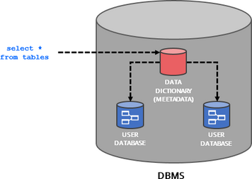

1. **Importance of Database Metadata in JDBC**

* Database metadata in JDBC, provided through the DatabaseMetaData interface, plays a critical role in allowing Java applications to dynamically discover information about the underlying database and its structure.

1. **Methods provided by DatabaseMetaData (getDatabaseProductName, getTables, etc.)**

* **it as information about tables, columns, supported features, and more.**

1. **getDatabaseProductName()**
2. **getDatabaseProductVersion()**
3. **getDriverName()**
4. **getTables()**
5. **getColumns()**
6. **getPrimaryKeys()**
7. **getImportedKeys()**
8. **getExportedKeys()**
9. **supportsTransactions()**
10. **getFunctionColumns()**
11. **getSchemas()**
12. **getMaxColumnsInTable()**
13. **supportsBatchUpdates()**